# Python address book

## Explanation of my final project

My final project is a python program that collects user information and creates an address entry for a contact

The program is designed to allow the Admin to create a contacts list manager that can be used to **CREATE**, **READ**, **UPDATE** and **DELETE** a record.

## Application settings

Before this program can run you will need to have the following plugins and dependencies included.from [**easygui**](http://easygui.sourceforge.net/) import *  
import sys  
import re

once you have extracted the files you should run addressBook.py this will open the EasyGui interface prompting you to enter a series of questions. Once you have completed the program creates a text file which stores the data in key value pairs. We then continue to use this data file to perform additional actions such as viewing your contacts, editing contacting, searching contacts and deleting contacts.

## How the program behaves

When the program starts you are presented with a series of inputs to add an entry to you address book. The first entry will ask you to name your book.

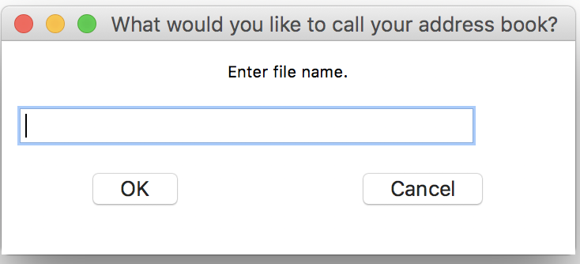

The name you provide will generate a .txt file which we use to store all the contact entries.

You will not be able to leave any data fields empty without a warning. After you have created the address book name you are presented with a series of choices for populating the book. ***See figure 1***

Figure 1

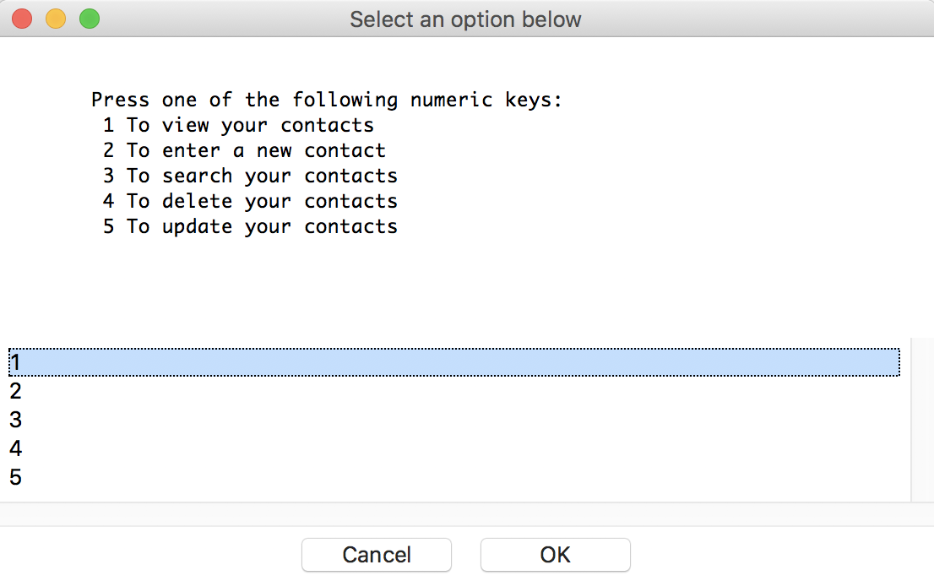

Each address entry is assigned a contact ID stored in key value pairs which allows us to make modifications to the entries

{"cid": "1", "first_name": "Jeff", "last_name": "Mccommas", "telephone": "1 (617) 230-0763", "email": "jeff@gmail.com", "address": "123 street Boston USA"} {"cid": "2", "first_name": "Fred", "last_name": "Jones", "telephone": "1 (978) 954-1236", "email": "fred@gmail.com", "address": "321 street Boston USA"}

## Unit tests

I have created several unit tests on one of my classes and its methods. The class which contains the unit tests is: classes/JsonDictHelper.py

run this command python3 classes/JsonDictHelper.py which will print out: see figure 2

Figure 2

